**TESTING ASSIGNMENT**

**What is SDLC ?**

Software Development Life Cycle is structure imposed on the development of the software product that defined the process of planning, testing, documentation, implementation and ongoing maintenance and process.

**What is software testing?**

Software Testing is a process used to identify the correctness, completeness, and quality of developed computer software.

**Write SDLC phases with basic introduction**

1. Requirement collection
2. Analysis
3. Design
4. Implementation
5. Testing
6. Maintenance
7. Requirement collection :

Requirements definitions usually consist of natural language, supplemented by diagrams and tables.

Three types of problems can arise:

* Lack of clarity
* Requirement confusion
* Requirement amalgamation

Types of requirement:

* Functional requirement
* Non functional requirement

2.analysis:

* The analysis phase defines the requirements of the system
* This phase defines the problem that the customer is trying to solve
* The design may include the usage of existing components

3.design :

* Design Architecture Document Implementation Plan
* The requirement document must guide this decision process.

4. Implementation:

* In the implementation phase, the team builds the components either from scratch or by composition.
* The implementation phase deals with issues of quality, performance, baselines, libraries, and debugging.

5.testing:

* Simply stated, quality is very important.
* A customer satisfied with the quality of a product will remain loyal and wait for new functionality in the next version.

6.maintenance:

* Software maintenance is one of the activities in software engineering, and is the process of enhancing and optimizing deployed software

There are three types off maintenance:

* Corrective maintenance: identifying and repairing defects
* Adaptive maintenance: adapting the existing solution to the new platforms.
* Perfective Maintenance: implementing the new requirements

**Explain Phases of the waterfall model ?**

The classical software life cycle model the software development as a step by step “waterfall” between various development phases.

When to use?

* Requirements are very well documented, clear and fixed.
* Product definition is stable.
* The project is short

**Proc :**

* Simple and easy to understand and use
* Easy to manage due to the rigidity of the model.
* Phases are processed and completed one at a time.
* Works well for smaller projects**.**

**cons:**

* **Not a good model for complex and object-oriented projects. Poor model for long and ongoing projects.**
* **High amounts of risk and uncertainty**
* **It is difficult to measure progress within stages. Cannot accommodate changing requirements**

**Write phases of spiral model ?**

Spiral Model is very widely used in the software industrythe natural development process of any productand also involves minimum risk for the customer

1. Planning
2. Risk analysis
3. engineering
4. Customer evaluation

Pros:

* Changing requirements can be accommodated.
* Users see the system early
* Development can be divided into smaller parts and more risky parts can be developed earlier which helps better risk management

Cons:

* Management is more complex.
* End of project may not be known early
* Not suitable for small or low risk projects
* Process is complex

**What is agile methodology?**

Agile model believes that every project needs to be handled differently and the existing methods need to be tailored to best suit the project requirements. In agile the tasks are divided to time boxes to deliver specific features for a release.

**What id SRS?**

A software requirements specification (SRS) is a complete description of the behavior of the system to be developed.

**What is oops?**

Oops stands for object oriented programming system. Blackbox and functional

**Write Basic Concepts of oops**?

1. Class
2. Object
3. Encapsulation
4. Polymorphism
5. Abstraction
6. Inheritance

**What is object ?**

Object is a instance of a class

**What is class ?**

Class is the collection of data member(variables)and member function(method or process) with its behaviours.

**What is encapsulation ?**

Data hiding, wrapping up of data into single unit.

**What is inheritance ?**

Properties of parents class exteds into child class. main purpose is reusability, extendsibility .

There are mainly 5 types

1. Single
2. Multilevel
3. Hierarchical
4. Multiple
5. hybrid

**What is polymorphism?**

Ability to take one name having different or many forms.

There are mainly 2 types

1. method overloading
2. method overriding

**Write agile manifesto principles?**

* + **Agile SDLC model is a combination of iterative and incremental process models with focus on process adaptability and customer satisfaction by rapid delivery of working software product.**
* **Agile Methods break the product into small incremental builds. These builds are provided in iterations.**
* **Each iteration typically lasts from about one to three weeks**

**Explain working methodology of agile model and also write pros and cons.?**

Agile model believes that every project needs to be handled differently and the existing methods need to be tailored to best suit the project requirements. In agile the tasks are divided to time boxes (small time frames) to deliver specific features for a release.

Pros

* Is a very realistic approach to software development Promotes teamwork and cross training.
* Functionality can be developed rapidly and demonstrated.
* Suitable for fixed or changing requirements.
* planned context.
* Little or no planning required Easy to manage
* Gives flexibility to developers

**Cons:**

* **Not suitable for handling complex dependencies.**
* **More risk of sustainability, maintainability and extensibility.**
* **Depends heavily on customer interaction, so if customer is not clear, team can be driven in the wrong direction.**
* **There is very high individual dependency.**

**Draw Usecase on online bill payment system (paytm)?**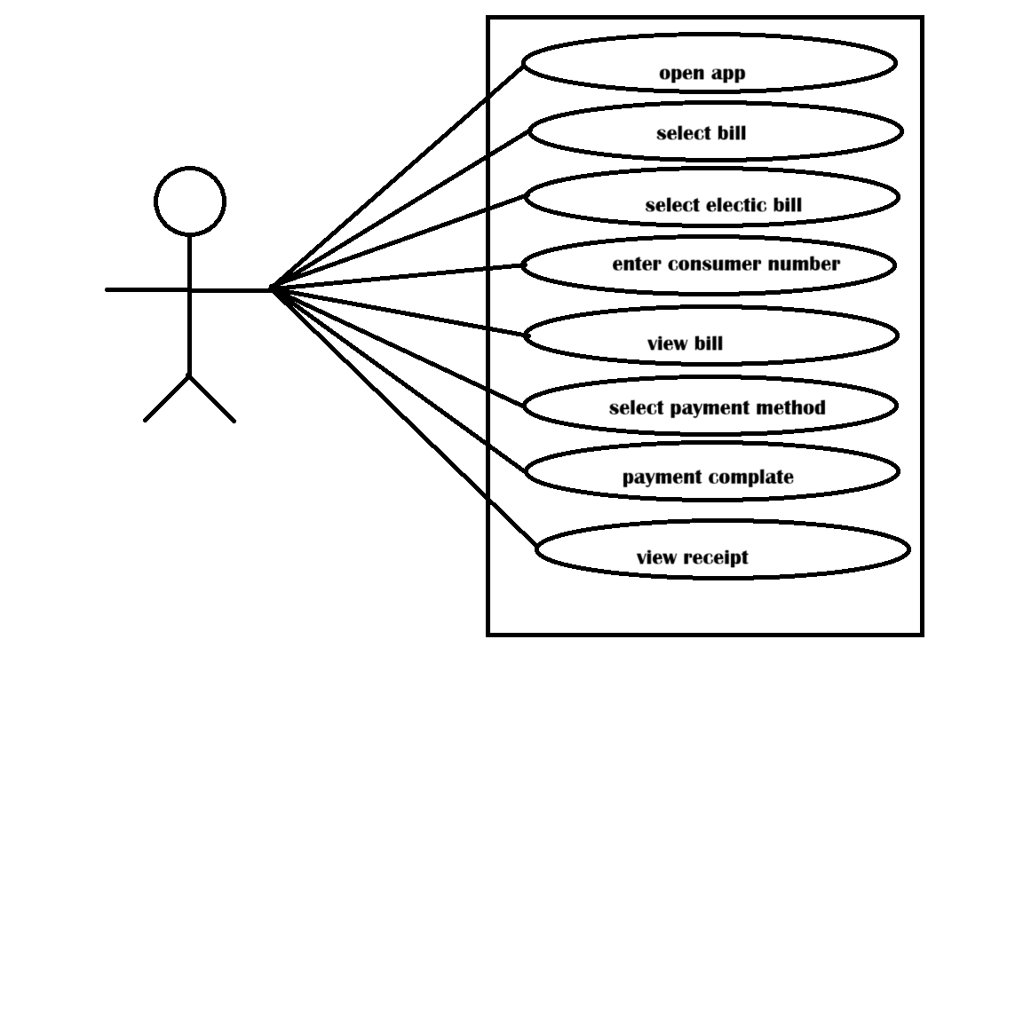

**Draw Usecase on banking system for customers?**

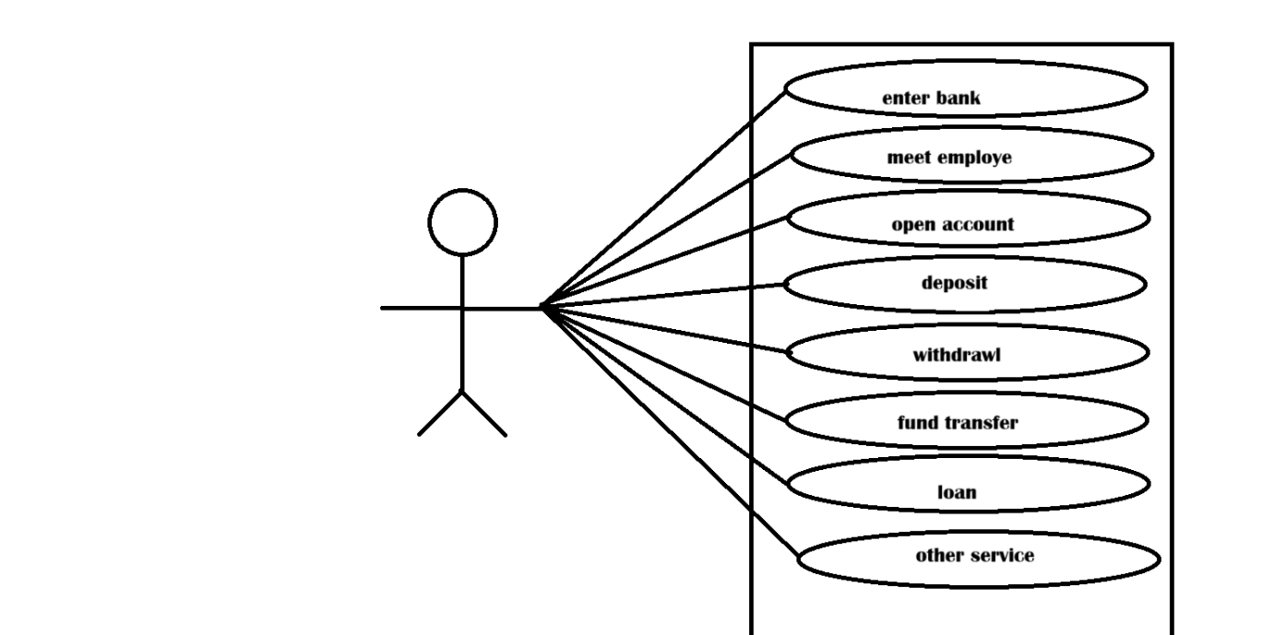

**Draw Usecase on Broadcasting System**?

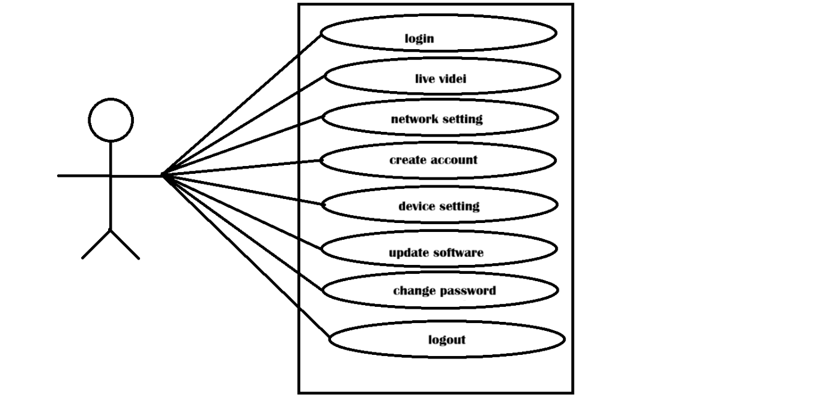

**Draw usecase on OTT Platform.**

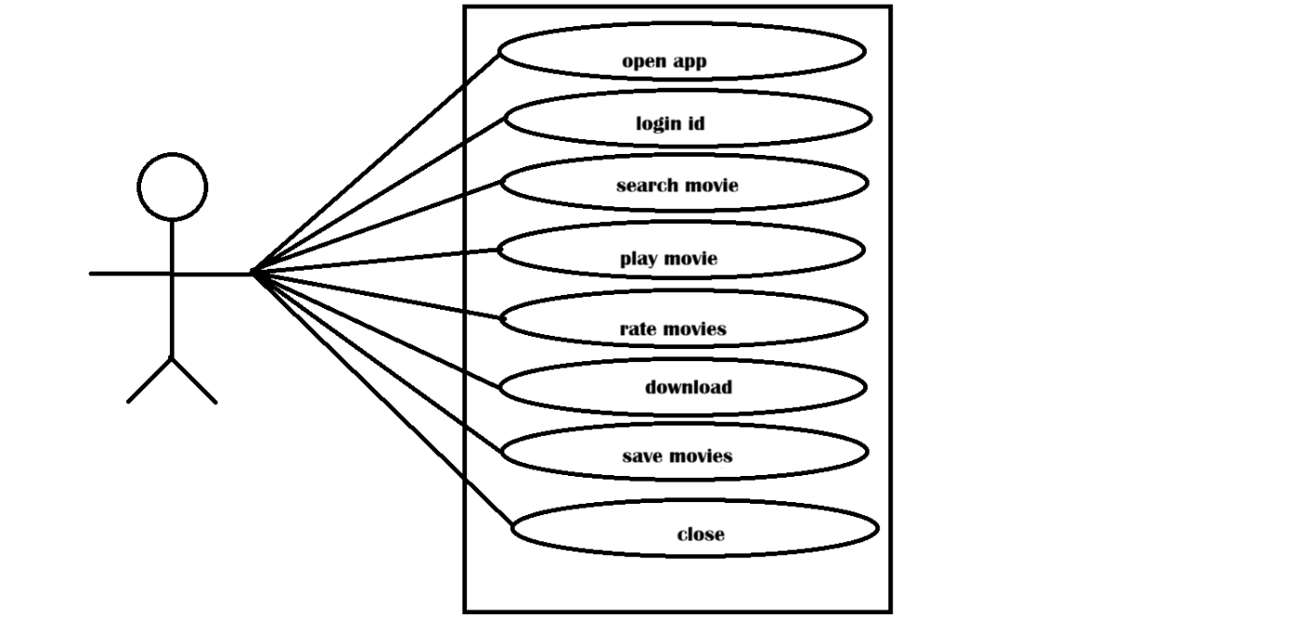

**Draw usecase on E-commerce application**

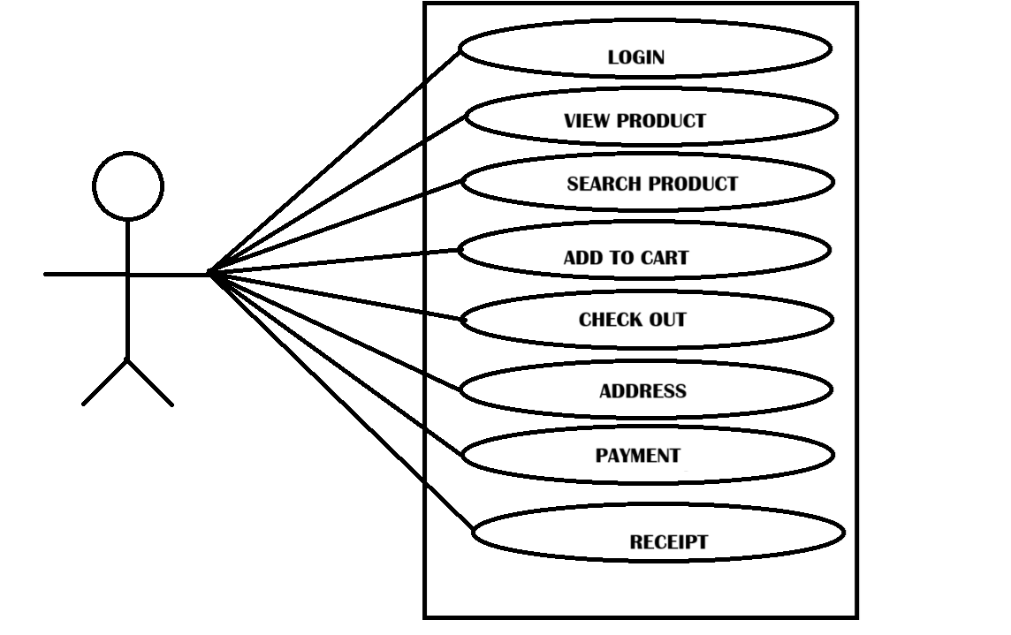

**Draw usecase on Online shopping product using payment gateway.**

